ISLAMIC UNIVERSITY OF TECHNOLOGY

Organization of Islamic Cooperation

Board Bazar, Gazipur

Laboratory Report

CSE 4512

**Title**: Configuring Network Address Translation (NAT) in Cisco Devices

**Objective**:

* Configure Dynamic NAT with Overload
* Verify Dynamic NAT with Overload Implementation
* Configure PAT using an Interface
* Verify PAT Interface Implementation

**Devices/Software Used**: Cisco Packet Tracer

**Theory**:

Static NAT: In Static NAT, we use one-to-one mapping between a local and a global address. This basically just provides us with some security by hiding the private IP. It does not help with reducing the number of global IPs required.

Dynamic NAT: In Dynamic NAT, a pool of global addresses is available. Whenever a local address requires a connection to the internet, one of the IP addresses from the pool is selected. When not in use, the global IP addresses is released into the pool again.

PAT: In Dynamic NAT, in the worst case, we may need as may global IP addresses as we have local ones, which makes the thing pointless. In Port Address Translation (PAT), multiple local addresses are mapped to a single global one. TCP or UDP port information is used to separate out which data comes from or goes to which internal host. Note that we still have multiple global addresses available, but we keep using the same one until it is no longer possible to assign a different port number for each device using the global address. Although this can theoretically happen, practically, it does not.

**Diagram of the experiment(s)**:

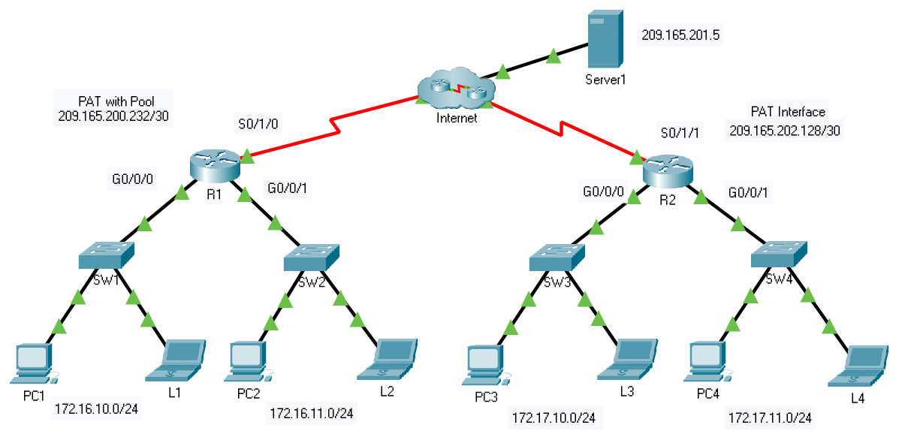

**Working Procedure**:

1. Configured Dynamic NAT with Overload on R1.

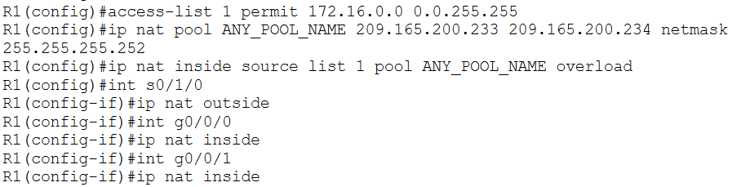

1. Verified connections between all PCs connected to R1 and Server1.

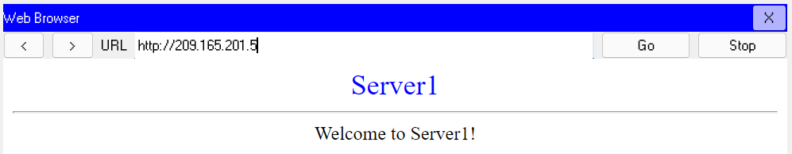

1. Viewed NAT translations on R1.

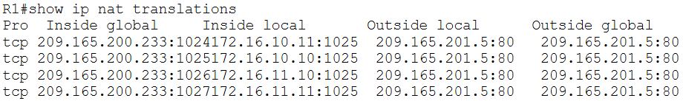

1. Configured PAT on R2.

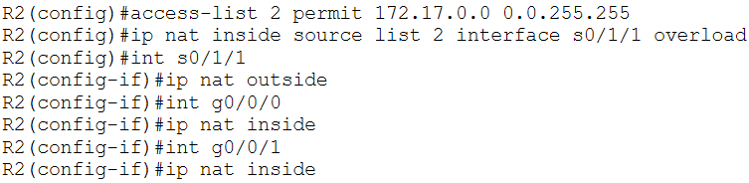

1. Verified connections between all PCs connected to R2 and Server 1.

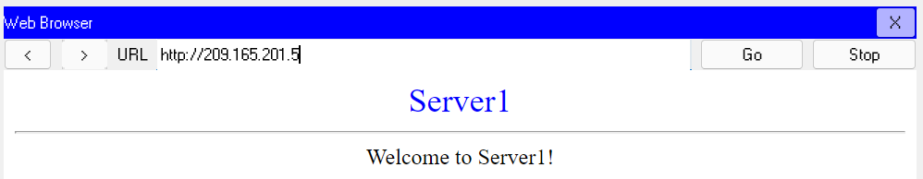

1. Viewed NAT translations on R2.

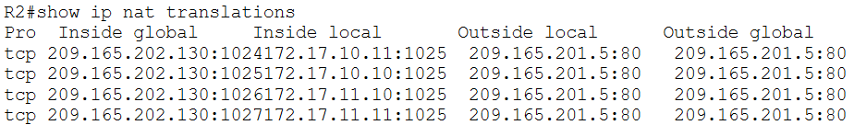

1. Compared NAT statistics between R1 and R2.

R1:

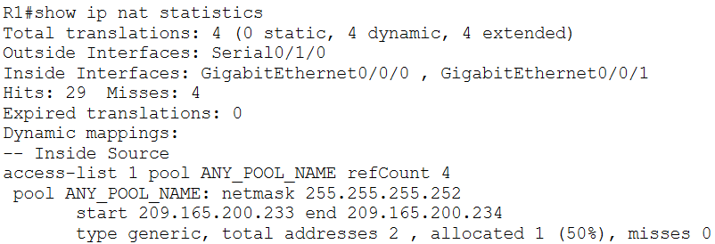

R2:

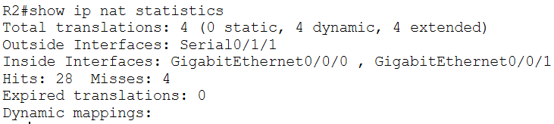

**Questions**:

Task # 01:

From the web browser of each of the PCs that use R1 as their gateway (PC1, L1, PC2, and L2), access the web page for Server1.

Question: Were all connections successful?

Answer: Yes

From the web browser of each of the PCs that use R2 as their gateway (PC3, L3, PC4, and L4), access the web page for Server1.

Question: Were all connections successful?

Answer: Yes

Compare the NAT statistics on the two devices.

Question: Why doesn’t R2 list any dynamic mappings?

Answer: In R1, a pool was used for the global addresses, so the local addresses had to be mapped onto one of the global addresses from the pool dynamically. In contrast, on R2, a single interface is being used to map local addresses to a global one. This involves no dynamic mapping.